Apex Sheds
A well-built shed, designed to cater for all your garden storage needs The Apex shed can come with or without windows in your desired side, and hinges are chosen to your specification on order.
All Apex sheds can be constructed either a 16mm Tongue and Grooved Shiplap or a 22mm Log Lap cladding.
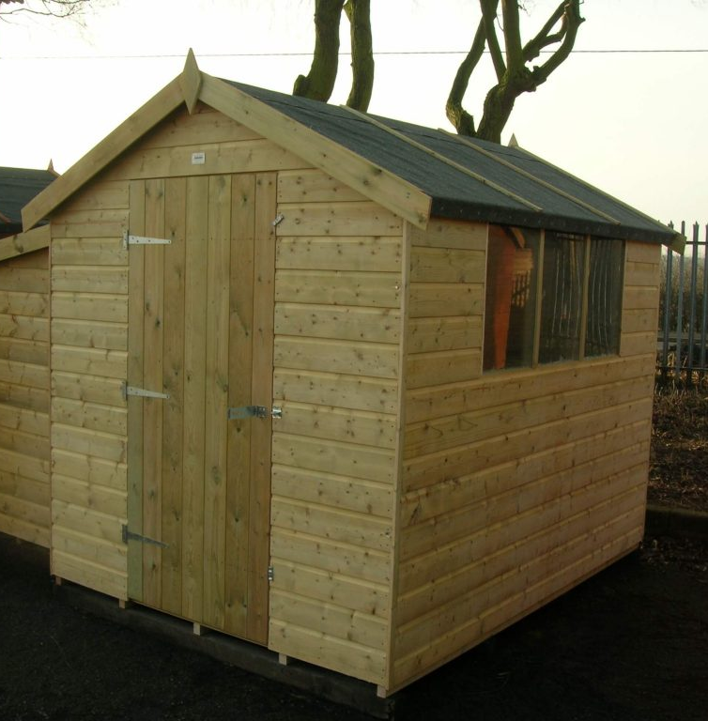
AVAILABLE IN:
4 x 4
6 x 4
6 x 5
7 x 5
8 x 6
9 x 7
10 x 6
12 x 6
8 x 8
10 x 8
12 x 8
14 x 8
16 x 8
10 x 10
12 x 10
14 x 10
- Pressure treated timber throughout
- Ex 38mm x 50mm framework throughout
- Swedish/Russian saw falling red/white wood timber
- Tongued and grooved matching board floor and roof (16mm nominal/12mm finished)
- Tongued and grooved shiplap to walls (16mm nominal/12mm finished)
- Galvanised fittings throughout
- Roof beads on top of the felt
- Eaves Height – 5’4″
- Ridge Height – 7’1″
- Delivery and installation – Free (within our standard delivery radius)

Security Apex
Constructed with a secure slit window, deadlock and bolted hinges. The roof is also fixed internally for added security. Can be produced in both 16mm nominal Tongued and grooved board or 22mm nominal Log Lap.

AVAILABLE IN:
4 x 4
6 x 4
6 x 5
7 x 5
8 x 6
9 x 7
10 x 6
12 x 6
8 x 8
10 x 8
12 x 8
14 x 8
16 x 8
10 x 10
12 x 10
14 x 10
- Pressure treated timber throughout
- Ex 38mm x 50mm framework throughout
- Swedish/Russian saw falling red/white wood timber
- Tongued and grooved matching board floor and roof (16mm nominal/12mm finished)
- Tongued and grooved shiplap to walls (16mm nominal/12mm finished)
- Galvanised fittings throughout
- Roof beads on top of the felt
- Eaves Height – 5’4″
- Ridge Height – 7’1″
- Delivery and installation – Free (within our standard delivery radius)

Pent Sheds
Offering the ultimate in design flexibility with the option of doors and window placement anywhere on the 4 sides of the building. Also the roof can be “reversed” to have the slope in the opposite direction. Available in both our 16mm nominal Tongued and Grooved Cladding or our 22mm nominal Log Lap.
AVAILABLE IN:
4 x 4
6 x 4
6 x 5
7 x 5
8 x 6
9 x 7
10 x 6
12 x 6
8 x 8
10 x 8
12 x 8
14 x 8
16 x 8
10 x 10
12 x 10
14 x 10

- Pressure treated timber throughout
- Ex 38mm x 50mm framework throughout
- Swedish/Russian saw falling red/white wood timber
- Tongued and grooved matching board floor and roof (16mm nominal/12mm finished)
- Tongued and grooved shiplap to walls (16mm nominal/12mm finished)
- Galvanised fittings throughout
- Roof beads on top of the felt
- 6′ Wide and Under – 6’6″ down to 6′
- 7′ Wide and Over – 7′ down to 6′
- Delivery and installation – Free (within our standard delivery radius)

Apent Sheds
Apent sheds offer the flexibility of a pent style shed, with the advantage of extra height from the off-centred apex roof. Available in both 16mm nominal Tongued and Grooved cladding or 22mm nominal Log Lap.
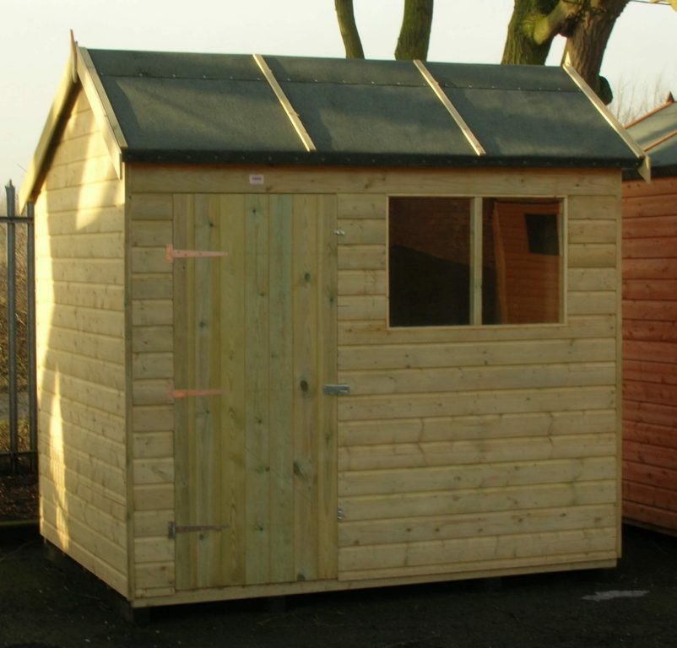
AVAILABLE IN:
4 x 4
6 x 4
6 x 5
7 x 5
8 x 6
9 x 7
10 x 6
12 x 6
8 x 8
10 x 8
12 x 8
14 x 8
16 x 8
10 x 10
12 x 10
14 x 10

- Pressure treated timber throughout
- Ex 38mm x 50mm framework throughout
- Swedish/Russian saw falling red/white wood timber
- Tongued and grooved matching board floor and roof (16mm nominal/12mm finished)
- Tongued and grooved shiplap to walls (16mm nominal/12mm finished)
- Galvanised fittings throughout
- Roof beads on top of the felt
- Eaves Height – 6’6? Front/6? Rear
- Ridge Height – 8’1?
- Delivery and installation – Free (within our standard delivery radius)

Workshops
Offering an extra foot in height compared to a standard Apex from the eaves (approximately 6’4”) and 8’ (Approximately) at the ridge. The Workshop also comes with the option of either a 3’ single door or a 4’ double door as a standard feature and windows (if required) in your desired location. Finally can be cladded in with Tongued and Grooved board or upgraded to Log Lap.
AVAILABLE IN:
10 x 10
12 x 10
14 x 10
16 x 10
18 x 10
20 x 10
12 x 12
14 x 12
16 x 12
18 x 12
20 x 12
AVAILABLE IN:
7 x 5
8 x 6
10 x 6
12 x 6
14 x 6
8 x 8
10 x 8
12 x 8
14 x 8
16 x 8
18 x 8
20 x 8

- Pressure treated timber throughout
- Ex 38mm x 50mm framework throughout
- Swedish/Russian saw falling red/white wood timber
- Tongued and grooved matching board floor and roof (16mm nominal/12mm finished)
- Tongued and grooved shiplap to walls (16mm nominal/12mm finished)
- Galvanised fittings throughout
- Roof beads on top of the felt
- Eaves Height – 6’4″
- Ridge Height – 8’1″
- Delivery and installation – Free (within our standard delivery radius)

Dutch Barns
A popular option with our customers, offering something a little different in design when a sloping or pitch roof isn’t quite right. Coming with the option of either a 3’ single door or a 4’ double door as standard, but it doesn’t stop there, the Dutch barn features a high level internal shelf as standard which is very useful for additional storage.

AVAILABLE IN:
8 x 6
10 x 6
12 x 6
14 x 6
8 x 8
10 x 8
12 x 8
14 x 8
16 x 8
18 x 8
20 x 8
AVAILABLE IN:
10 x 10
12 x 10
14 x 10
16 x 10
18 x 10
20 x 10
12 x 12
14 x 12
16 x 12
18 x 12
20 x 12

- Pressure treated timber throughout
- Ex 38mm x 50mm framework throughout
- Swedish/Russian saw falling red/white wood timber
- Tongued and grooved matching board floor and roof (16mm nominal/12mm finished)
- Tongued and grooved shiplap to walls (16mm nominal/12mm finished)
- Galvanised fittings throughout
- Roof beads on top of the felt
- Eaves Height – 5’9″
- Ridge Height – 8’1″
- Delivery and installation – Free (within our standard delivery radius)

Square Fronted Potting Shed
Supplied with a stable door on either the left or right hand gable to suit the desired position in the garden
This model has the added benefit of additional storage underneath the window and a 16″ wide Potting Shelf.
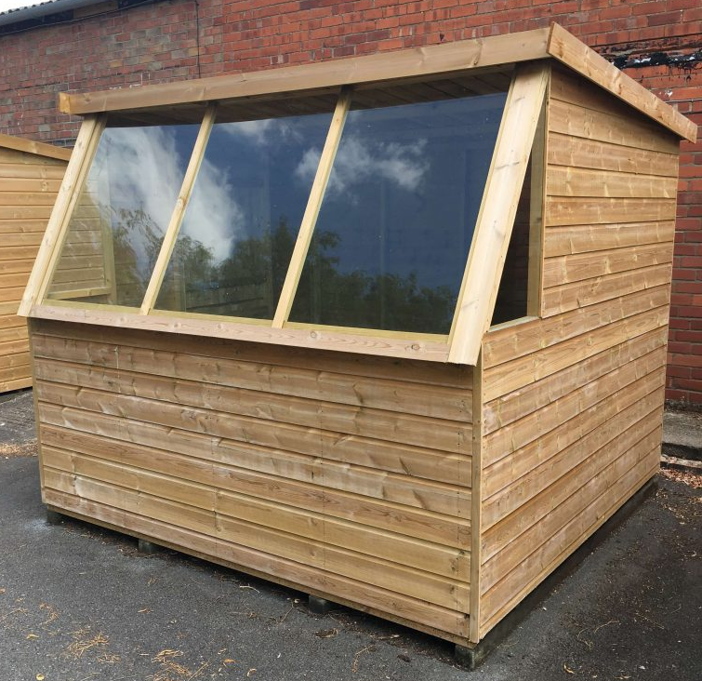

AVAILABLE IN:
6 x 4
7 x 5
8 x 7’4”
10 x 6
8 x 8
10 x 8
12 x 8

- Pressure treated timber throughout
- Ex 38mm x 50mm framework throughout
- Swedish/Russian saw falling red/white wood timber
- Tongued and grooved matching board floor and roof (16mm nominal/12mm finished)
- Tongued and grooved shiplap to walls (16mm nominal/12mm finished)
- Galvanised fittings throughout
- Roof beads on top of the felt
- 6′ Deep and Under – 6’6″ down to 6′
- 7′ Deep and Over – 7′ down to 6′
- Delivery and installation – Free (within our standard delivery radius)

Return Fronted Potting Shed
Supplied with a stable door on either the left or right hand gable to suit the desired position in the garden. The Return Fronted Potting shed has a standard sized footprint but has extra space in the return front and is constructed with a 12” wide shelf across the full length of the window.

AVAILABLE IN:
6 x 4
7 x 5
8 x 6
10 x 6
8 x 8
10 x 8
12 x 8
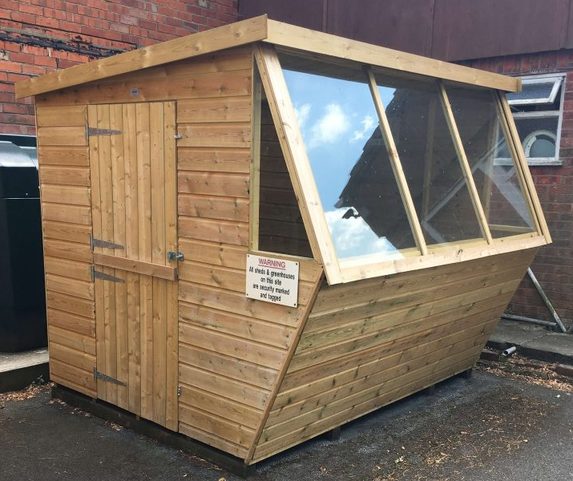
- Pressure treated timber throughout
- Ex 38mm x 50mm framework throughout
- Swedish/Russian saw falling red/white wood timber
- Tongued and grooved matching board floor and roof (16mm nominal/12mm finished)
- Tongued and grooved shiplap to walls (16mm nominal/12mm finished)
- Galvanised fittings throughout
- Roof beads on top of the felt
- 6′ Deep and Under – 6’6″ down to 6′
- 7′ Deep and Over – 7′ down to 6′
- Delivery and installation – Free (within our standard delivery radius)

Sun Trap
Proving to be a popular model with customers, the Sun Trap is similar to a potting shed but with vertical windows and features a 2’ wide shelf running across the width of the building. Also having Dutch Lite glazing across the front of the building and additional glazing either side.

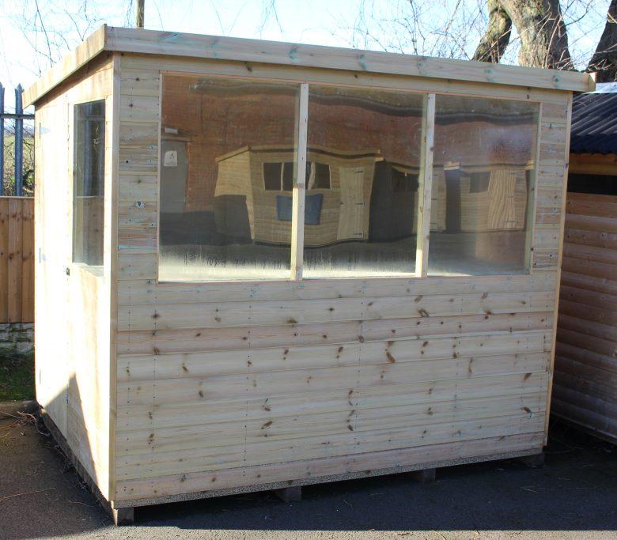
AVAILABLE IN:
4 x 4
6 x 4
6 x 5
7 x 5
8 x 6
9 x 7
10 x 6
12 x 6
8 x 8
10 x 8
12 x 8
14 x 8
16 x 8
10 x 10
12 x 10
14 x 10

- Pressure treated timber throughout
- Ex 38mm x 50mm framework throughout
- Swedish/Russian saw falling red/white wood timber
- Tongued and grooved matching board floor and roof (16mm nominal/12mm finished)
- Tongued and grooved shiplap to walls (16mm nominal/12mm finished)
- Galvanised fittings throughout
- Roof beads on top of the felt
- 6′ Wide and Under – 6’6″ down to 6′
- 7′ Wide and Over – 7′ down to 6′
- Delivery and installation – Free (within our standard delivery radius)

Tool Tidy
The tool tidy features a lower height to fit into small spaces but still with plenty of storage space inside. This building is ideal for fitting underneath windows and where space is limited. Double doors as standard and no windows.
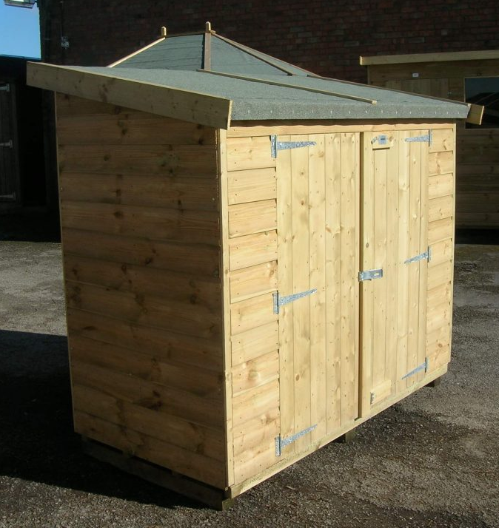

AVAILABLE IN: 6 X 3

- Pressure treated timber throughout
- Ex 38mm x 50mm framework throughout
- Swedish/Russian saw falling red/white wood timber
- Tongued and grooved matching board floor and roof (16mm nominal/12mm finished)
- Tongued and grooved shiplap to walls (16mm nominal/12mm finished)
- Galvanised fittings throughout
- Roof beads on top of the felt
- Double doors on the front as standard.
- Delivery and installation – Free (within our standard delivery radius)

Tongued and Grooved Apex Cabin
As the name suggests, this Cabin comes in our Tongued and Grooved board as standard, also this summerhouse is one of our best sellers due to its very affordable price. The Cabin can come with or without a 3’ Veranda.
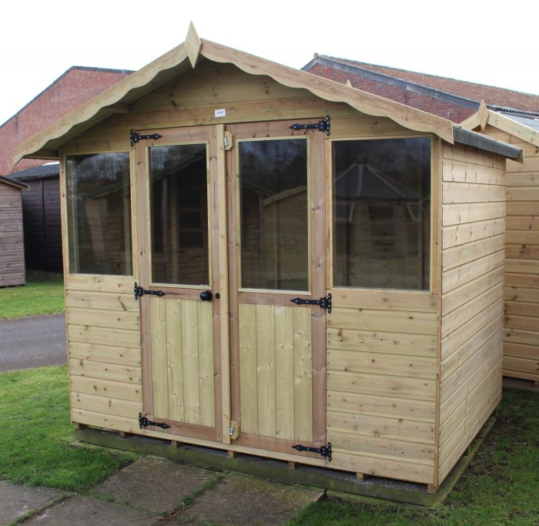
AVAILABLE IN:
8 X 6
8 X 8
10 X 6
10 X 8
12 X 6
12 X 8
ALL AVAILABLE WITH A 3’ VERANDA AT AN ADDITIONAL COST

- Pressure treated timber throughout
- Ex 38mm x 50mm framework throughout
- Swedish/Russian saw falling red/white wood timber
- Tongued and grooved matching board floor and roof (16mm nominal/12mm finished)
- Tongued and grooved shiplap to walls (16mm nominal/12mm finished)
- Galvanised fittings throughout
- Roof beads on top of the felt
- Delivery and installation – Free (within our standard delivery radius)

Tongued and Grooved Pent Cabin
Featuring our 16mm nominal Tongued and Grooved cladding, showcasing the ever popular pent style sloping roof which offers a little something different to a classic summerhouse. Coming as Standard with 4′ Double doors, one fixed window and a 12” Decking.

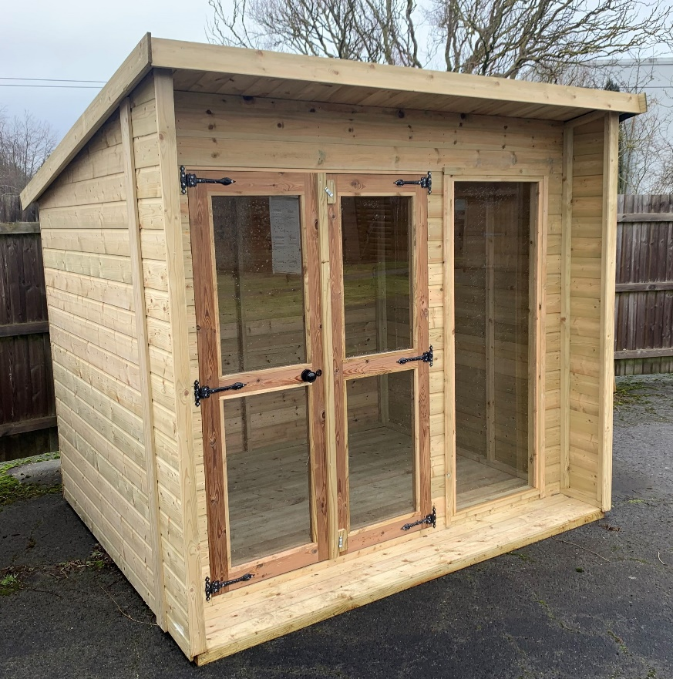

AVAILABLE IN:
8 X 6
8 X 8
10 X 6
10 X 8
ALL AVAILABLE WITH A 3’ VERANDA AT AN ADDITIONAL COST

- Pressure treated timber throughout
- Ex 38mm x 50mm framework throughout
- Swedish/Russian saw falling red/white wood timber
- Tongued and grooved matching board floor and roof (16mm nominal/12mm finished)
- Tongued and grooved shiplap to walls (16mm nominal/12mm finished)
- Galvanised fittings throughout
- Roof beads on top of the felt
- Delivery and installation – Free (within our standard delivery radius)

Combination Cabin
This building has proven to be very popular solution for many customers, as it offers the benefit of both a summerhouse and a separate area for storage. This combination unit is available in both tongued and grooved cladding or log lap and of course comes in a range of sizes.
AVAILABLE IN:
**FEATURING 1 X SET OF 4’ WIDE WINDOWS, HALF GLAZED SUMMER HOUSE DOORS, 2 X FIXED WINDOWS, ONE LENGTH PF PARTITION AND 1 X FULLY FRAMED 2’6” PERSONAL DOOR**
12 X 6
12 X 8
12 X 10
12 X 12
14 X 6
14 X 8
14 X 10
14 X 12
ADDITIONAL 2’ DEPTH AND 3’ VERANDA AVAILABLE AT AN ADDITIONAL COST

- Pressure treated timber throughout
- Ex 38mm x 50mm framework throughout
- Swedish/Russian saw falling red/white wood timber
- Tongued and grooved matching board floor and roof (16mm nominal/12mm finished)
- Tongued and grooved shiplap to walls (16mm nominal/12mm finished)
- Galvanised fittings throughout
- Roof beads on top of the felt
- Delivery and installation – Free (within our standard delivery radius)

Victorian Cabin
This Cabin offers something slightly more unusual for your garden, due to quaint Victorian style roof. The building features a number of fixed windows and glazed doors providing a light and airy space to enjoy in your garden.
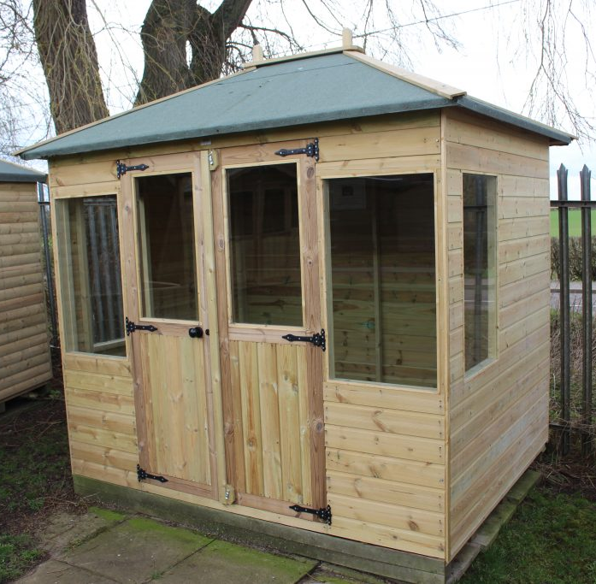

AVAILABLE IN: 8X6

- Pressure treated timber cladding and framework
- Ex 38mm x 50mm framework throughout
- Swedish/Russian saw falling red/white wood timber
- Tongued and grooved matching board floor and roof (16mm nominal/12mm finished)
- Tongued and grooved shiplap to walls (16mm nominal/12mm finished)
- Ply roof
- Galvanised fittings throughout
- Roof beads on top of the felt
- Delivery and installation – Free (within our standard delivery radius)

Log Lap Chalet
Another very sought-after building, this chalet will really shine in any garden. Available with or without a 3’ veranda offering a shaded place to sit out.

AVAILABLE IN:
8 X 6
8 X 8
10 X 6
10 X 8
12 X 6
12 X 8
3’ VERANDA AVAILABLE AT AN ADDITIONAL COST

- Pressure treated timber throughout
- Ex 38mm x 50mm framework throughout
- Swedish/Russian saw falling red/white wood timber
- Tongued and grooved matching board floor and roof (16mm nominal/12mm finished)
- Log Lap – (22mm nominal/19mm finished)
- Galvanised fittings throughout
- Roof beads on top of the felt
- Delivery and fitting is free! Inside our 70 mile delivery radius
- Delivery within 4 weeks from receipt of order – check with our sales team for current lead times!

Log Lap Chalet with Wings
The Chalet with wings offers the benefit of a slightly overhanging roof canopy to provide a larger amount of cover, useful for all weathers. This chalet is clad in our 22mm barrel profiled log lap board as standard, featuring a set of 4’ wide half glazed summerhouse doors and two side opening windows allowing for plenty of light and fresh air to populate your summerhouse.
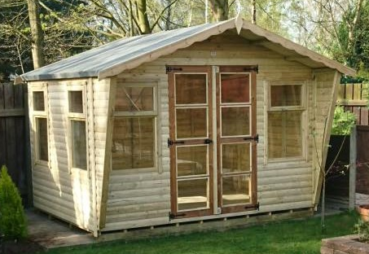

AVAILABLE IN:
8 X 6
8 X 8
10 X 6
10 X 8
12 X 6
12 X 8
3’ VERANDA AVAILABLE AT AN ADDITIONAL COST

- Pressure treated timber throughout
- Ex 38mm x 50mm framework throughout
- Swedish/Russian saw falling red/white wood timber
- Tongued and grooved matching board floor and roof (16mm nominal/12mm finished)
- Log Lap – (22mm nominal/19mm finished)
- Galvanised fittings throughout
- Roof beads on top of the felt
- Delivery and fitting is free! Inside our 70 mile delivery radius
- Delivery within 4 weeks from receipt of order – check with our sales team for current lead times!

Studio
Featuring an overhanging roof covering the front aspect of the summerhouse, providing either cooling shade on the hot days in the summer or some protection from the elements during the less summery days. Featuring long top opening windows and 5ft wide summerhouse doors. Comes as standard with onduline roofing, guttering and downpipe.
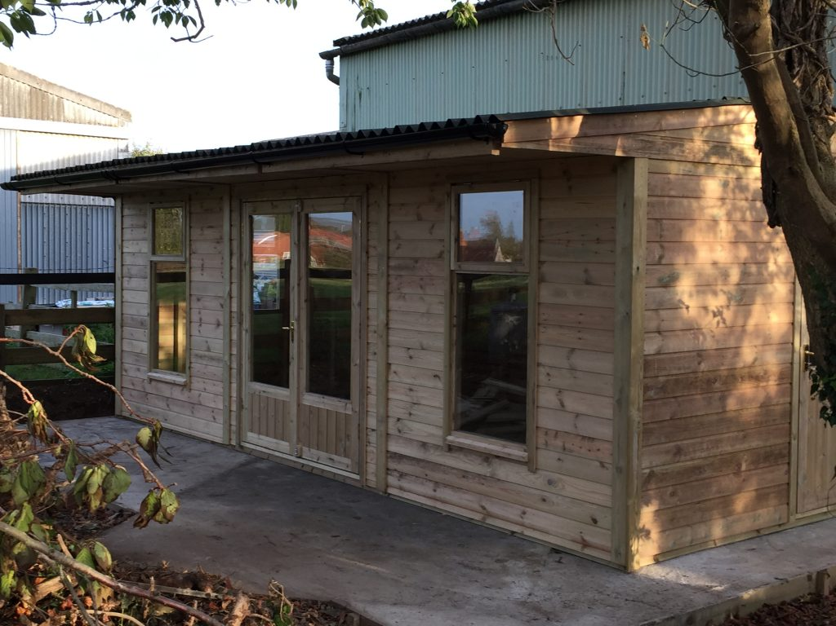

AVAILABLE IN:
12 x 12
12 x 10
12 x 8
14 x 12
16 x 12
16 x 10
16 x 8
18 x 12
20 x 12
22 x 12
24 x 12
DECKING VERANDA AND HANDRAILS 5’ DEEP AVAILABLE FOR ADDITONAL COST

- Pressure treated timber throughout
- Ex 75mm x 47mm quality softwood framework throughout
- Roof Purlins 100mm x 47mm (4” x 2”)
- Swedish/Russian saw falling red/white wood timber
- Tongued and grooved matching board floor and roof (16mm nominal/12mm finished)
- Tongued and grooved shiplap to walls (19mm nominal/15mm finished)
- Galvanized fittings throughout
- Black Onduline roof sheeting as standard – virtually maintenance free
- Guttering included
- Glazing in 4mm toughened glass
- Brass door and window furniture
- Delivery and installation – Free (within our standard delivery radius)

Alpine Lodge
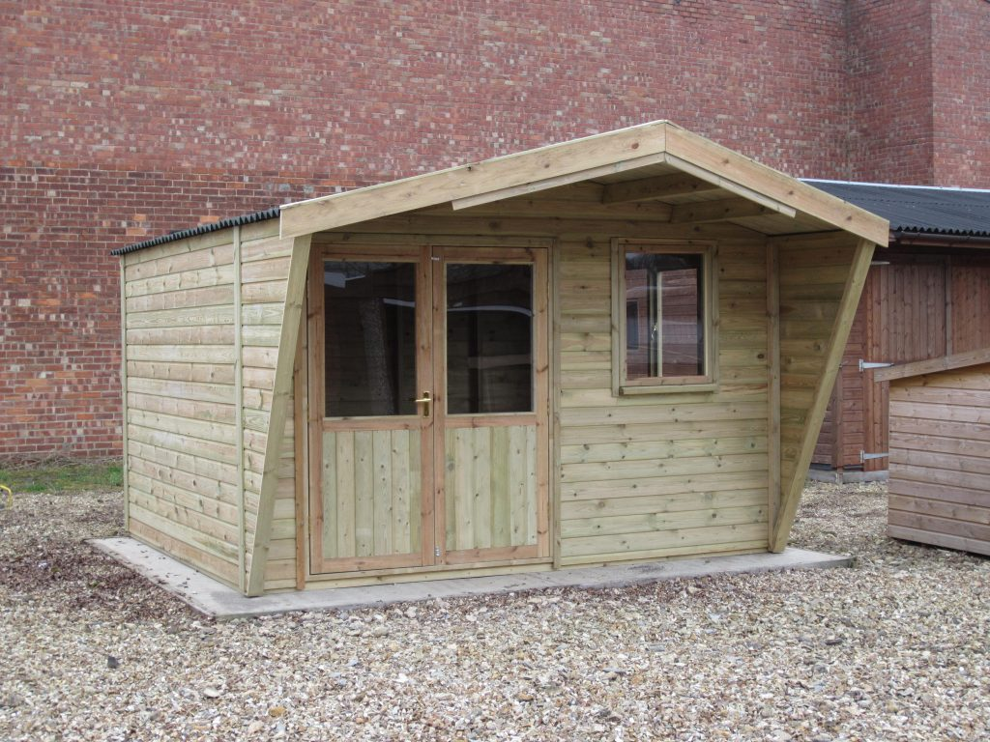
Available in both tongued and grooved cladding and our heavier duty log lap boarding. The Alpine Lodge’s appearance is slightly reminiscent of a log cabin, with its front overhang and wings offering some much needed shelter from the sun on a hot day.
AVAILABLE IN:
12x8
12x10
12x12
16x10
16x12

- Pressure treated timber throughout
- Ex 75mm x 47mm quality softwood framework throughout
- Roof Purlins 100mm x 47mm (4” x 2”)
- Swedish/Russian saw falling red/white wood timber
- Tongued and grooved matching board floor and roof (16mm nominal/12mm finished)
- Tongued and grooved shiplap to walls (19mm nominal/15mm finished)
- Galvanized fittings throughout
- Black Onduline roof sheeting as standard – virtually maintenance free
- Guttering included
- Glazing in 4mm toughened glass
- Brass door and window furniture
- Delivery and installation – Free (within our standard delivery radius)

Kirton Lodge
One of our most popular models. The Kirton Lodge offers a light and airy but very useable and practical space, ideal for those seeking the more modern alfresco lifestyle.
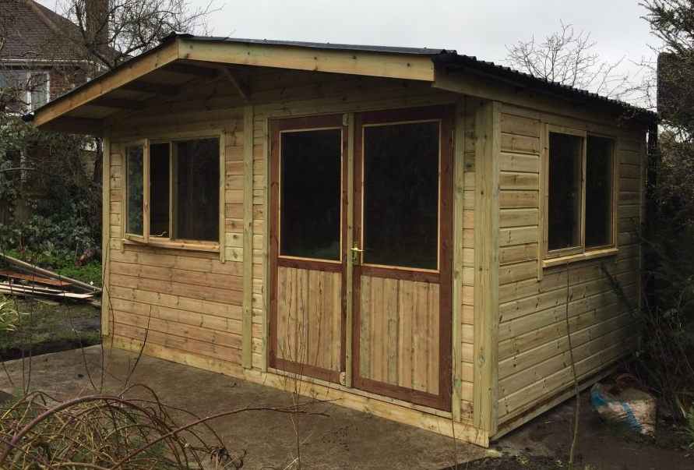

AVAILABLE IN;
13x13

- Pressure treated timber throughout
- Ex 75mm x 47mm quality softwood framework throughout
- Roof Purlins 100mm x 47mm (4” x 2”)
- Swedish/Russian saw falling red/white wood timber
- Tongued and grooved matching board floor and roof (16mm nominal/12mm finished)
- Tongued and grooved shiplap to walls (19mm nominal/15mm finished)
- Galvanized fittings throughout
- Black Onduline roof sheeting as standard – virtually maintenance free
- Guttering included
- Glazing in 4mm toughened glass
- Brass door and window furniture
- Delivery and installation – Free (within our standard delivery radius)

Retreat
Featuring a 1.2m veranda with a stylish chevron pattern, which offers an outdoor seating area or somewhere to fire up the barbeque, with the added advantage of having the indoor space of the summerhouse still to enjoy.
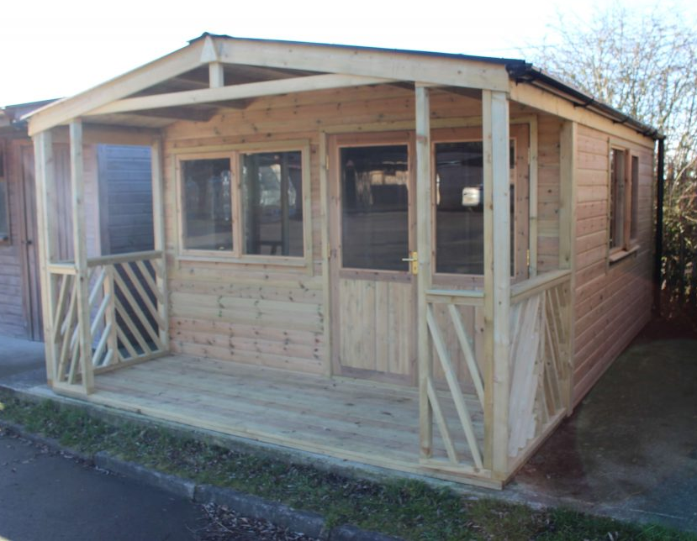

AVAILABLE IN;
12’ x 8’ with 4’ veranda
12’ x 10’ with 4’ veranda
12’ x 12’ with 4’ veranda

- Pressure treated timber throughout
- Ex 75mm x 47mm quality softwood framework throughout
- Roof Purlins 100mm x 47mm (4” x 2”)
- Swedish/Russian saw falling red/white wood timber
- Tongued and grooved matching board floor and roof (16mm nominal/12mm finished)
- Tongued and grooved shiplap to walls (19mm nominal/15mm finished)
- Galvanized fittings throughout
- Black Onduline roof sheeting as standard – virtually maintenance free
- Guttering included
- Glazing in 4mm toughened glass
- Brass door and window furniture
- Delivery and installation – Free (within our standard delivery radius)

Octagonal Summerhouse
Can be clad in either our tongue and groove or log lap boards, the summerhouse fits neatly into a corner or as a central focus point and internally offers a really open feel due to the vaulted shape of the roof. This summerhouse can be manufactured in three different sizes and will be a real feature in any garden.

AVAILABLE IN ;
6’ X 6 Octagonal Summerhouse
8’ x 6’ Octagonal Summerhouse
10’ x 8’ Octagonal Summerhouse

- Pressure treated timber cladding and frame
- Ex 38mm x 50mm framework throughout
- Swedish/Russian saw falling red/white wood timber
- Tongued and grooved matching board floor and roof (16mm nominal/12mm finished)
- Tongued and grooved shiplap to walls (16mm nominal/12mm finished)
- Ply roof
- Galvanised fittings throughout
- Roof beads on top of the felt
- Delivery and installation – Free (within our standard delivery radius)

Corner Summerhouse
The ideal solution for that wasted corner in the bottom of your garden. This can be manufactured in 4 different sizes and comes as standard with a set of half glazed summerhouse doors and two large top opening windows.
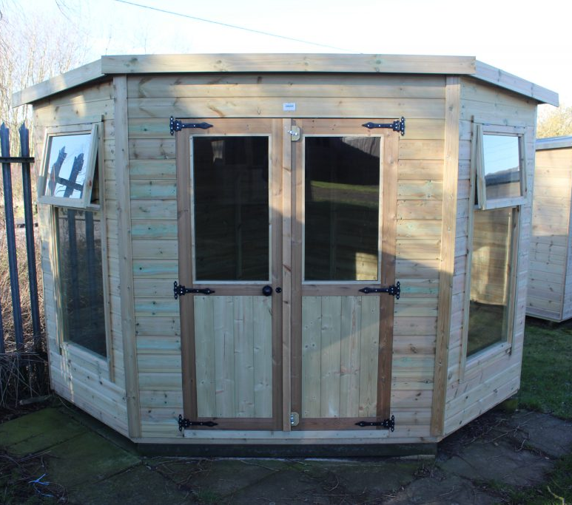

AVAILABLE IN ;
6’ x 6’ Corner Summerhouse
7’ x 7’ Corner Summerhouse
8’ x 8’ Corner Summerhouse
10’ x 10’ Corner Summerhouse

- Pressure treated timber throughout
- Ex 38mm x 50mm framework throughout
- Swedish/Russian saw falling red/white wood timber
- Tongued and grooved matching board floor and roof (16mm nominal/12mm finished)
- Tongued and grooved shiplap to walls (16mm nominal/12mm finished)
- Galvanised fittings throughout
- Roof beads on top of the felt
- Delivery and installation – Free (within our standard delivery radius)

Children’s Playhouses
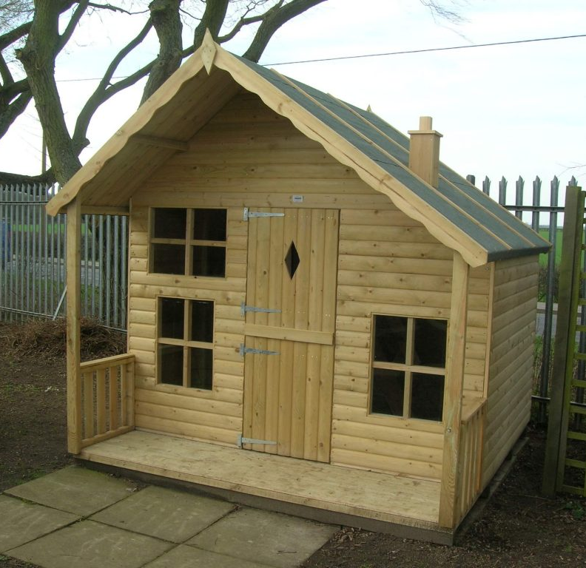
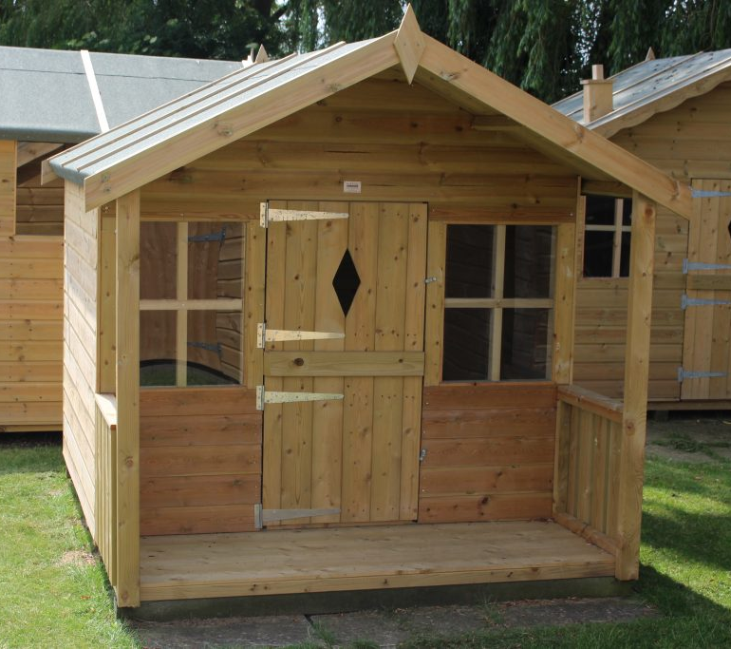
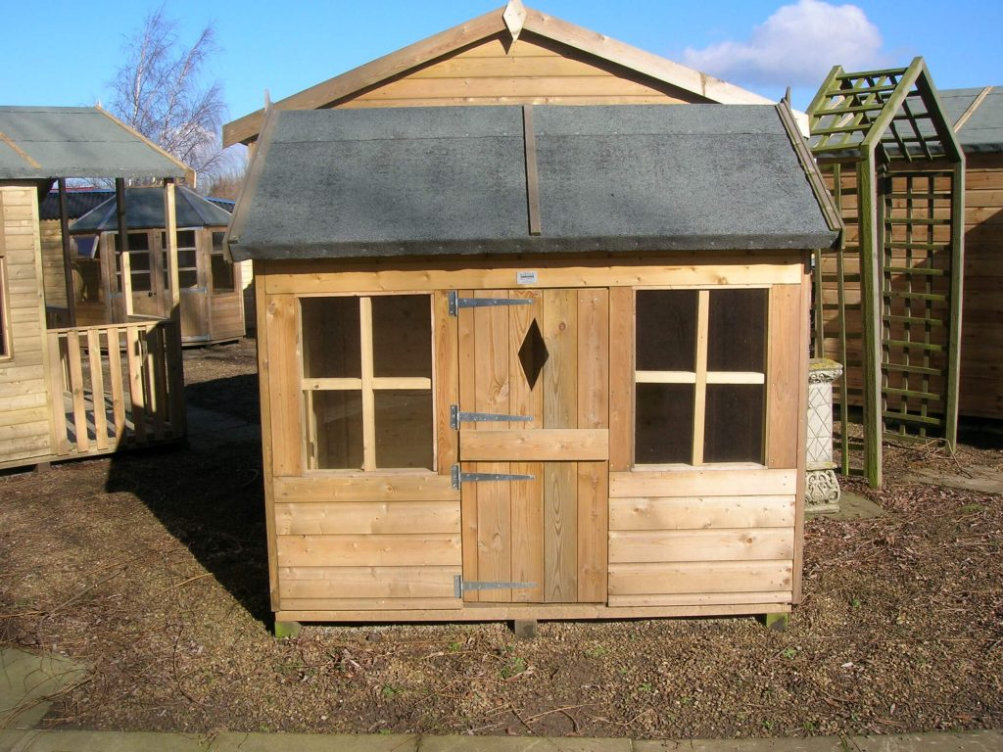
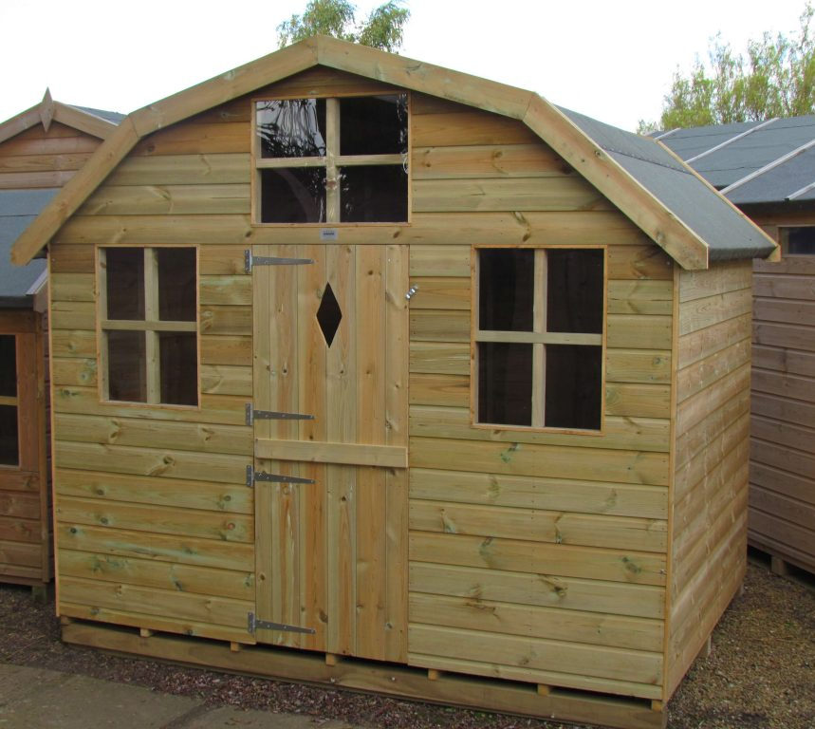
WENDY HOUSE
6 x 4 Wendy House comes with windows and stable door. This is great for small spaces, a lovely building for smaller children

PLAYDEN
8 x 6 log lap Playden comes with a 2’ veranda, stable door, loft ladder and upper level. Very popular with older children

THE PLAY BARN
8 x 6 Play Barn comes with barn style vaulted roof, stable door, bunk and stairs
THE PLAYHOUSE
6 x 5 Playhouse comes with a 2’ veranda and stable door. A great little house with an outside area with shade or protection from the rain.

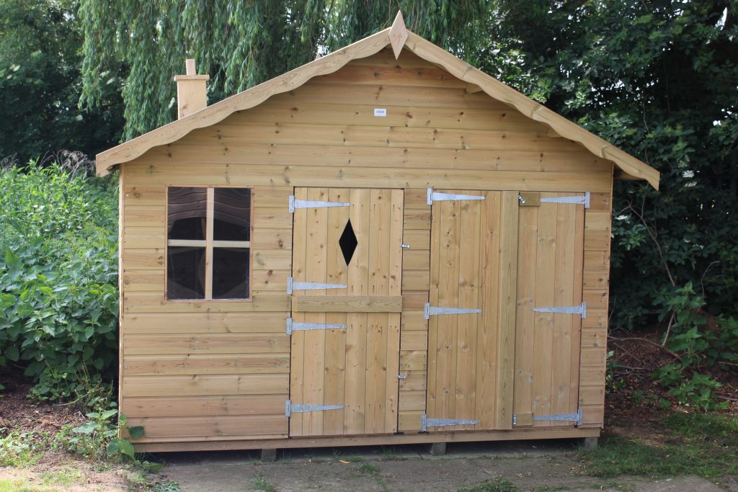
The Bungalow
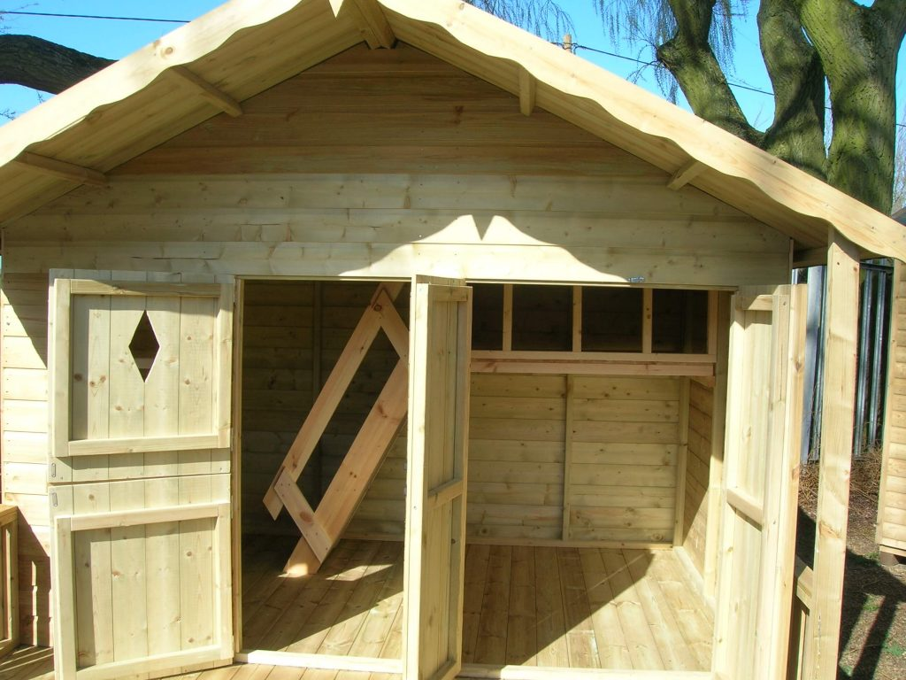

9‘x6’ Bungalow
One of our most versatile play buildings. It has two compartments and comes as standard with a stable door, garage doors and an internal partition, enabling children to have a storage area and a play area. Available with or without a 2’ veranda and with an upper level and staircase as an optional extra.

Ordering information and terms and conditions

Thank you for taking a look at our selection of sheds and garden buildings.
For up to date prices on any of our buildings, please contact the office by telephone on 0114 3270430 or by email on
millhousesfencingandsheds@outlook.com or by using the contact us form on the website.
There are many optional extras available on all the buildings such as, heavy duty felt, onduline roofing, extra or opening windows, 3’ doors, double doors, half and full glazed doors and many security extras. Please ask if you require any extra information. Many of the buildings can also be made in non-standard sizes.
All our sheds and garden buildings are fully pressure treated and prices include delivery, fitting onto your own flat and level base, VAT and a tub of waterproofing for you to seal the shed once it is in situ (we can also provide a base fitting service if required and can arrange for the waterproofing to be added before delivery if space is limited)
Upon ordering, a delivery date will be agreed and a 50% deposit will be taken, the final 50% is taken the day before delivery and payments can be made by card or bank transfer.
Terms and conditions
Assembly is offered on the understanding that a prepared base is ready and that access to the site is acceptable, i.e. customers have advised us in advance of any height or width restrictions or tight turns (such as having to go through the house or a gateway or turn a 90 degree corner) That the delivery does not include a distance of more than 45 metres from the kerbside to the proposed site (any distance beyond this will carry a surcharge) That the shed does not need to be lifted over a wall, fence or garage. Failure to inform us of any of these things may result in the building being left for self-assembly (no refund of the assembly charge will be given) or the building being left at the customer’s property and a new assembly date given for after the issues are solved, which will incur a £100 charge (£150 if the building has to be returned to our site and redelivered)

